

**KHULNA UNIVERSITY OF ENGINEERING & TECHNOLOGY**

Department of Computer Science and Engineering (CSE)

**COURSE NO:** CSE 3104

**Course Title:** Peripherals and Interfacing Laboratory

**Project Title: Smart Blind Stick**

***Submitted To:***

**1.Mohammad Insanur Rahman Shuvo**

Assistant Professor

Department of Computer Science and Engineering (CSE)

Khulna University of Engineering & Technology (KUET)

**2. Md. Motaleb Hossen Manik**

Lecturer

Department of Computer Science and Engineering (CSE)

Khulna University of Engineering & Technology (KUET)

***Submitted by:***

**Name**: Subah Nawar, **Roll**: 1807006

**Name**: Shaikh Prothomaa Binte Minhaz, **Roll**: 1807010

**Name**: Sazia Akhter Tushi, **Roll**: 1807026

**Year**: 3rd

**Semester**: 1st

**Submission Date**: July 26, 2022

**Objectives:**

1. To provide sound and motor-based assistance to blind people to make their life easier and independent
2. To provide a device for blind people that can detect obstacles and hole
3. To provide an application for the visually impaired persons that help them to sense fire and water
4. To know about Arduino-Uno and its application in real life
5. To know about Ultrasonic sensors, water sensors, fire sensor, LDR, GSM

**Introduction:**

Eyesight is one of a person's most important abilities that help him get information about his surroundings and the brain will process that information. Those who have the visual acuity of 6/60 or the horizontal extent of the visual field with both eyes open less than or equal to 20 degrees, these people are considered blind. Globally, at least one billion people have vision impairment.

Visually impaired persons are unable to see their surroundings and detect obstacles, fire, or water. Our project application may help them reduce their limitations and make them independent.

The smart blind stick is designed to detect obstacles at a certain distance around them and in front of their head, and also help them to sense the object by vibration motor and buzzer. This blind stick can detect objects at different heights of objects and also sense a hole by ultrasonic sensor. For different heights, the buzzer gives them different sound frequencies. The system can detect fire and water by fire sensor and water sensor. Blind people can sense fire by vibration and buzzer, and sense water by the only buzzer. They also can send message to a specific phone number and there is also used LDR with LED and LED is ON in dark place so that people can detect them.

**Project Description:**

The smart blind stick is a device for the visually impaired to guide the user to their respective destination and avoiding to collide with obstacles. It will use ultrasonic sensor HCSR04 to detect the obstacles in front of their head and foot. Along with that, it will use Arduino as the main controller. In this application, we use fire and water sensor, and also have a buzzer and a motor to alert them.

Whenever there is any obstacle in its range i.e. less than 60cm, the sensor will detect the distance from the obstacle and send it to controller. The controller will make the buzzer sound and vibrate. In our application, it can detect obstacles in front of their face.

When the sensors do not detect an object, in this condition the buzzer and motor will be stopped.

Fire and water sensors work in the process as the ultrasonic sensor HCSR04 works. The controller will make the buzzer sound and vibrate when it gets the signal from fire sensor and the controller will make only the buzzer when it gets the signal from the water sensor, and is in touch with water.

In our project, we have used LDR which is a photo-resistor that is used to detect light & change the operation of a circuit dependent upon the light levels. We add a LED light which is automatically ON when the light levels in surroundings so that at night they are not getting pushed by strangers while walking.

Through this application, Blind people can send messages to a given mobile number to give someone information about his current status.

We add this function by the GSM module.

It will also help blind people to detect an obstacle-free path by guiding them on whether to go right or to go left. The project will be portable or efficient and it will also be of low cost and low power consumption.

**Methodology:**

• The working of the system begins when the power supply is given.

• The Smart Blind Stick will have an Ultrasonic Sensor, Vibration motor, Water Sensor, Arduino UNO, Buzzer, Fire sensor, LDR, GSM module.

• All the components are connected to Arduino UNO and the sonar of the sunglass is connected to Arduino NANO for processing.

• Basically, the ultrasonic sensors work according to that and if any obstacles come across the blind stick detects the obstacles as an input function.

• Then, after receiving the input from the ultrasonic sensors, it will notify the user by giving the notification in the form of sound. The sound frequency will change according to the obstacle position

• The ultrasonic sensor operates by producing sound waves at a frequency that is too high for humans to hear from the 'TRIG' pin. The 'ECHO' pin is used to wait for the sound to be reflected back from a barrier.

• The time is used to calculate the distance between the sensor and the user. The equation distance = (velocity * time) / 2 is employed. The speed of sound (0.030 cm/s) is used here as velocity.

• The water sensor and fire are also utilized to determine water obstacles and fire. For water obstacles, it will only vibrate and for fire it will vibrate and make a sound. A fire detector works by detecting heat. These devices respond to the presence of smoke or extremely high temperatures that are present with a fire. After the device has been activated, it will send a signal to the alarm system to perform the programmed response for that zone.

•In the dark and at low light levels, the resistance of an LDR is high and little current can flow through it and in bright light, the resistance of an LDR is low and more current can flow through it.

•A sunglass that helps a blind person to detect a branch of tree appeared in front of him .we added this to our project so that it can alarm our user about obstacles in front of his head. The sonar will calculate the distance of the obstacle and notify user in the form of sound.

• We have added GSM module so that blind men can send emergency message when he will press the switch. If the switch is kept on, the module will send message after every 6000miliseconds.

**Flow Chart:**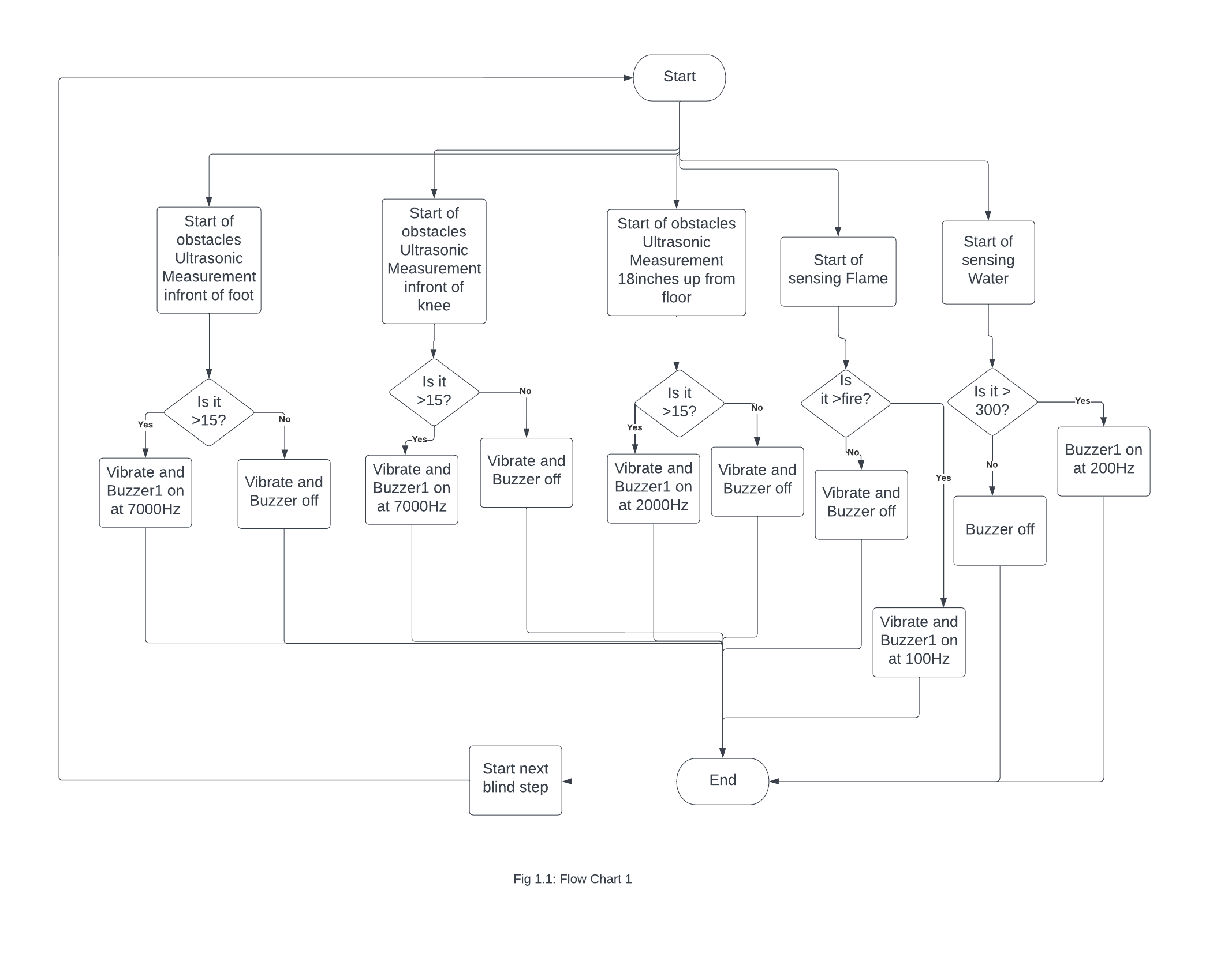

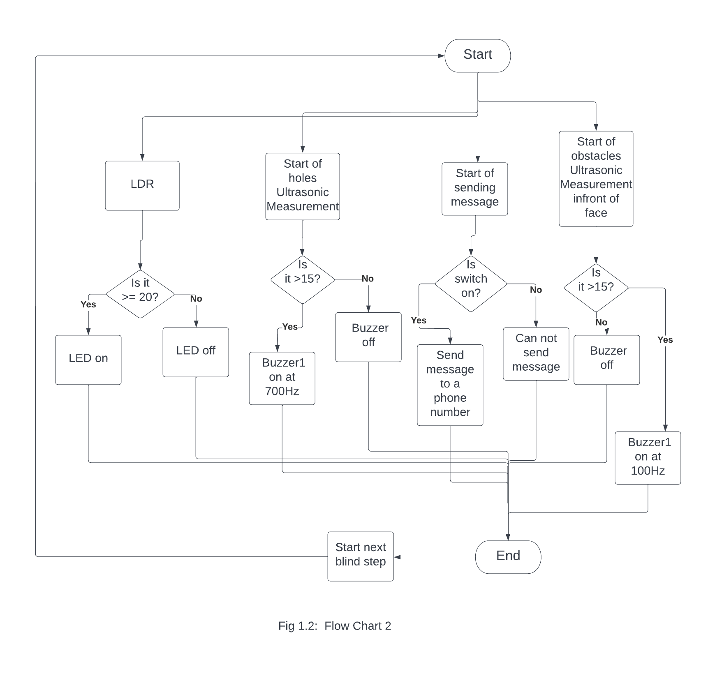

**Components Required:**

**Table 1.1:** Table for required components is

|  |  |  |  |
| --- | --- | --- | --- |
| SL No | Name of the Component | Rating | Quantity |
| 1 | Arduino Uno | Voltage: 6-20V  Digital I/O pins: 14  DC current: 40mA | 02 |
| 2 | Sonar | Voltage: DC 5V  Current: 15mA | 04 |
| 3 | Buzzer | Rated voltage: 5V  Max rated current:<=32mA | 02 |
| 4 | Battery | Voltage: 9V  Capacity: 1200mAh | 03 |
| 5 | LED diode | Power dissipation:80Mw  Current: 20-100MA  Voltage: 5V  Operating temperature range: -250 to +800C | 01 |
| 6 | Cable tie clips | - | As required |
| 7 | PVC pipe | Diameter ¾ inch  Length 2 meter | 01 |
| 8 | 9v battery connector | Dimension: 28mm x 15.8mm x 6.3mm  Length: 18cm | 01 |
| 9 | Vibration motor with Arduino | Rated voltage: 3.7V  Rated current: 0.07A | 01 |
| 10 | Jumper wire | - | As required |
| 11 | Fire sensor | Rated voltage: 3.3-5V | 01 |
| 12 | Water sensor | Rated current: 1-19mA  Detecting range:  40 x 16 mm | 01 |
| 13 | GSM | SIM800A | 01 |
| 14 | Arduino Nano | Voltage: 5V, power: 1 watt, Digital I/O Pins: 22 | 01 |
| 15 | LDR | Dark resistance: max 20Mohm  Light resistance: 10-20kohm | 01 |
| 16 | switch | Rating: 12V-250V AC/DC, Up to 10A AC/DC | 02 |
| 17 | Sunglass | - | 01 |

**Discussion:**

In our project “Smart Blind Stick”, we wanted to add some more functionality like a GPS system. Through this system, a selected one can detect the position of blind people by receiving radio waves. So that if the blind man is in danger that selected person can reach out to the blind man to rescue him. Also, the added functions like sonar, fire sensor, and water sensor are time-consuming in giving response because of instrumental error or connection error. But we tried our best to handle those problems to make our project perfect.

**Conclusion:**

Smart blind stick helps blind people to detect obstacles while they are walking and also help them to find an obstacle-free path with ease. This is a low-cost project. As a result, many blind people will be able to use it. It is also a very flexible gadget to serve mankind. Besides, continuous and tireless effort, the guidance of my respected teachers has also shaped this project as a successful outcome. I would like to express my humble gratitude for their valuable advice. Hence it can be said that the project was overall successful.

**References:**

1. <https://transmitter.ieee.org>
2. <https://www.youtube.com/watch?v=_RpSaj9j-GY>
3. <https://www.youtube.com/watch?v=ki8fj71Af30&t=25s>
4. <https://www.youtube.com/watch?v=KnLCkVib3u0&t=285s>
5. <https://www.youtube.com/watch?v=72DBEkGgu-w>
6. <https://www.youtube.com/watch?v=72DBEkGgu-w>